Additional Reference Info
General site on fish habitat with link to fish sticks info
http://dnr.wi.gov/topic/Waterways/habitat/fish_wildlife.html
Fish stick site on WI DNR with links to application and best practices manual
http://dnr.wi.gov/topic/fishing/outreach/fishsticks.html
Price County Zoning and Land Conservation which further links to other sites on Shoreland Zoning. http://www.co.price.wi.us/237/Zoning-Land-Conservation

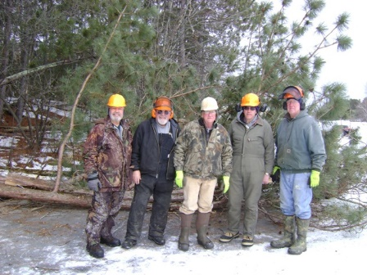

Attention shoreline property owners on the Phillips Chain
Would you like to help improve the fishing on the Chain?
Participate in the Fish Sticks Project with the Phillips Chain O Lakes Association
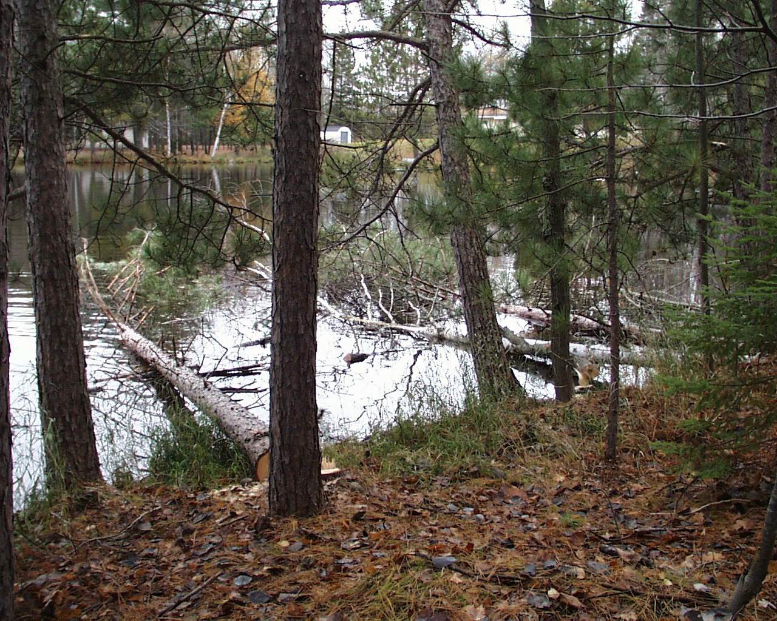
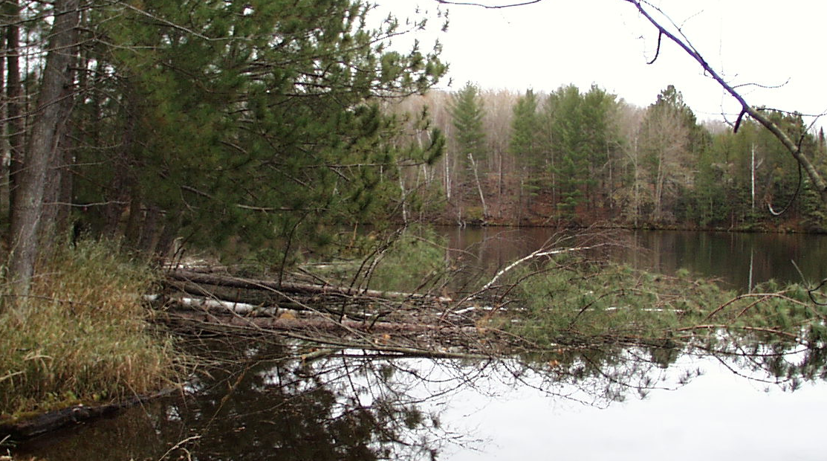
What
The Phillips Chain O Lakes Association is planning a project to install “fish sticks” on the Phillips Chain. Fish sticks are single trees or groupings of trees that are placed in the lake near shore and are securely anchored to the shore. Trees that are cut 35’ or less from the shore are restricted by the Shoreland Zoning Ordinance and would require working closely with Price County Zoning to assure compliance. There is more flexibility in using trees harvested inland more than 35’ but they require additional expense to move to the placement location.
Why
These trees provide valuable near shore habitat for wide variety of fish species, reptiles, and insects. Per Jeff Scheirer-Fishery Biologist, Wisconsin Department of Natural Resources “..placing complex woody structure in the form of whole trees in the shallow, near –shore zone has been shown to increase the overall productivity in lake ecosystems”.
How
The placement of fish sticks in the Phillips chain requires a permit from the Wisconsin Department of Natural Resources. Fish stick permit applications require detailed information about the location where fish sticks will be placed and how they will be placed. The Price County Land Conservation Department has agreed to assist with filling out the applications and preparing the site plans. The permit requires the land owner where the fish sticks will be placed to be the permit applicant or co-applicant. The Phillips Chain O Lakes Association will be a co-applicant on fish stick applications for this project and will work with land owners through the permitting process and successful installation of the fish sticks. The lake association will cover the permit application fees for this project and the cost of the tree anchors. The intent is for landowners to be able to participate in this project at no cost. Separate permits are required for each lake that fish sticks are to be placed.
Who
We are looking for land owners on the Phillips chain that have a location suitable for the placement of fish stick and are interested in participating in this project. These land owners may or may not have suitable trees for the fish sticks on their property.
When
Fish stick permits allow additional land owners to be added to the permit for up to five years. Based on land owner interest, the initial permit application process can begin in late 2015. The initial placement of fish sticks is planned for 2016 with future installations to continue in subsequent years based on interest.
Contacts
Bill Ruff – Fish Sticks Project Coordinator – Phillips Chain O Lakes Association 715 339 3680
Blake Pluemer – President - Phillips Chain O Lakes Association 715 339 2445

